Probability Models Name:
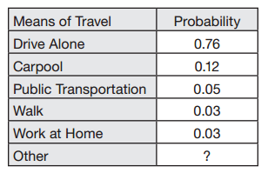
- In the United States, people travel to work in many different ways. The table below gives the distribution of responses to a survey in which people were asked their means of travel to work.

- What probability should replace the ? in this probability model?

- What is the probability that a randomly selected worker does not use public transportation to get to work or P(public transportation ^{c})

- What is the probability that a randomly selected worker drives to work (either alone or in a carpool)?

- What is the probability that a randomly selected worker does not drive to work (alone or in a car pool)?

- Use the probability model from the table below to answer the following questions:
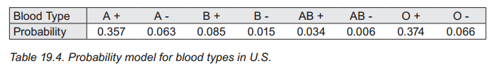
- Suppose a person is selected at random. Compute the probability that the person has Rh+ blood.

- Any patient with Rh+ blood can safely receive a transfusion of type O+ blood. What percentage of people in the U.S. can receive a transfusion of type O+ blood?

- The two most common blood types are O+ and A+. However, many people with O+ and A+ blood do not donate blood. One reason is the belief that because they have a common blood type, their blood is not needed. Is this a valid reason? Support your answer with percentages.

- Suppose two U. S. residents are randomly selected. Use the probability model to find the probability that they both have type O blood. P (O and O)

- Find the probability that exactly one of the two have type O blood or find P(O and O^{c}) or P(O^{c} and O)

- What is the probability that neither have type O blood? P(O^{c} and O^{c})

- According to the U.S. Energy Information Administration, about 51% of homes heat with natural gas. Let G represent homes that heat with gas and N represent homes not heated with gas. Suppose 3 homes are randomly selected.
- List the sample space for the 3 homes heating methods: (GGG means all 3 gas, GNG means first home gas, second not, and third home gas)
{

- List the outcomes for exactly one of the three homes heated with gas :

- List the outcomes for exactly two of the three homes heated with gas :

- List the outcomes for all 3 homes heated with gas

- List the outcomes for at least one home heats with gas

- Calculate the probabilities for each of the outcomes above (b-e)
P(exactly one G):

P(exactly two G):

P(all three G)

P(at least one G)

