Worksheet #1 – Solving & Graphing Equations and Inequalities

College Placement Exam Prep
Correct Number of Answers on Placement Exam Pre-Test for Questions 7 – 20: ________

Directions: Complete the appropriate section of the worksheet. Show all work!
- If you answered 0 – 5 questions correct, complete the problems in Section A of the worksheet.
- If you answered 6 – 10 questions correct, complete the problems in Section B of the worksheet.
- If you answered 11 – 14 questions correct, complete the problems in Section C of the worksheet.

Section A
Simplify each expression completely.
1. $21c+5d\left(1-c\right)-cd$ 2. $16j-4\left(7k-3j\right)+25k$

Solve each equation.
3. $6=-3(x+2)$ 4. $-3\left(1+6r\right)=14-4$ 5. $12\left(2k+11\right)=10(2k+12)$

Solve each inequality and graph the solution on a number line.
6. $4-d<3+2d$ 7. $-2\left(8-k\right)>-12$

Identify the slope, x-intercept, and y-intercept for each line.
8. $y=-4x+8$ 9. $3x+2y=-6$

Slope = ______ x-int = ______ y – int = ______ Slope = ______ x-int = ______ y – int = ______

Solve the system of equations by graphing, substitution, or elimination.
10. $\left\{\begin{aligned}5x+y=19 \\ -2x-y=-7\end{aligned}\right.$ 11. $\left\{\begin{aligned}2x+3y=4 \\ 4x-2y=-8\end{aligned}\right.$ 12. $\left\{\begin{aligned}–x+3y=12 \\ 6x-y=-21\end{aligned}\right.$

Solve the system of inequalities by graphing.
13. $\left\{\begin{aligned}y<2x+1 \\ y≥x\end{aligned}\right.$ 14. $\left\{\begin{aligned}y<x-4 \\ y>-3x+2\end{aligned}\right.$

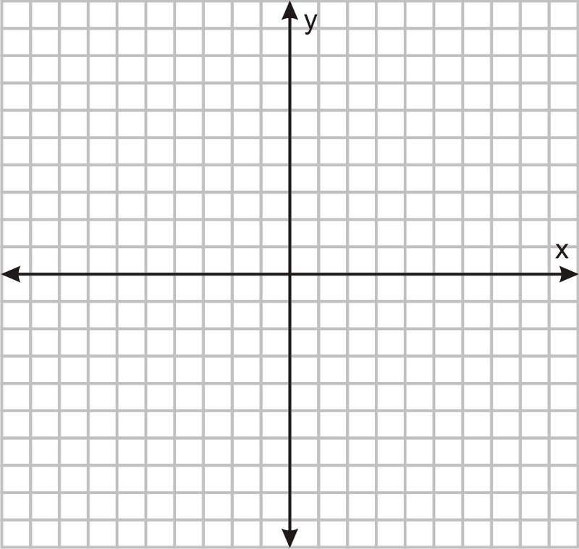

Section B
Simplify each expression completely.
1. $c\left(4c+d\right)-c^{2}+cd$ 2. $4a^{2}+5ab-4a^{2}-2ab-7$

Solve each equation.
3. $6\left(6v+6\right)-5=1+6v$ 4. $75=6(-n-3)$ 5. $-10+3\left(8+8x\right)=-6(x-4)$

Solve and graph on a number line.
6. $-5x+7≥-3$ 7. $4-(-7-k)>2(k+3)$

Identify the slope, x-intercept, and y-intercept for each line.
8. $5x+y=-5$ 9. $36x+2y=6$

Slope = ______ x-int = ______ y – int = ______ Slope = ______ x-int = ______ y – int = ______

Solve the system of equations by graphing, substitution, or elimination.
10. $\left\{\begin{aligned}x+y=13 \\ 2x-3y=1\end{aligned}\right.$ 11. $\left\{\begin{aligned}9x+2y=5 \\ 3x-y=-10\end{aligned}\right.$ 12. $\left\{\begin{aligned}2x+y=1 \\ x=5+y\end{aligned}\right.$

Solve the system of inequalities by graphing.
13. $\left\{\begin{aligned}y<3x-5 \\ y≤\frac{1}{2}x+4\end{aligned}\right.$ 14. $\left\{\begin{aligned}y<x+5 \\ y>4x-2\end{aligned}\right.$

Section C
Write an expression for the scenario. Simplify completely.
1. The width of a rectangle is $3g^{2}$ and the length of a rectangle is $h^{2}-2h+5$. Write a simplified expression representing the area of the rectangle.

2. What value(s) of $q$ will make the equation $2\left(x-q\right)=2x-1$ a contradiction?

Solve and graph on a number line.
3. $-18d+5(8+3d)≤7(3d-8)$

4. Draw a graph of a line with x-intercept (5, 0) and y-intercept (0, 8). Write the equation of the line in slope-intercept form.

Equation: ______________________________

Solve the system of equations by graphing, substitution, or elimination.
5. $\left\{\begin{aligned}3x-4y=5 \\ x=y+\frac{1}{2}\end{aligned}\right.$ 6. $\left\{\begin{aligned}3x+4y=35 \\ 4x-2y=21\end{aligned}\right.$ 7. $\left\{\begin{aligned}2x-8y=24 \\ x-21=16y\end{aligned}\right.$

Solve the system of inequalities by graphing.
8. $\left\{\begin{aligned}\begin{aligned}y<-3x+4 \\ y>-8\end{aligned} \\ y<x+5 \\ x>-6\end{aligned}\right.$

9. The Drama Club is selling tickets to a Senior Showcase. Prices are $8 for adults and $4 for student tickets. The club needs to raise $1000 to pay for stage sets and lighting. The auditorium has a seating capacity of 240 seats. Write a system of inequalities that can be used to determine how many tickets have to be sold for the club to meet its goal.

