Probability Review
AP STATS

- Bobby randomly chooses a ball from his toy chest. Create a probability model:

Outcome Red Ball Blue Ball Yellow Ball
Probability

- You spin each spinner one time. What is the probability that both spinners will land on A?

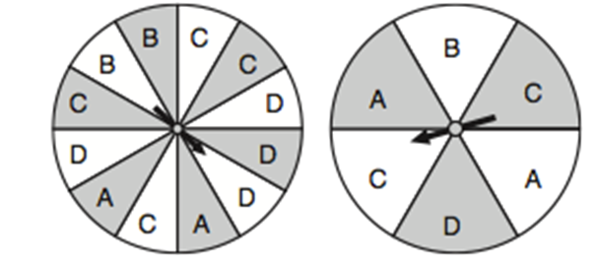

P(A and A) = __________

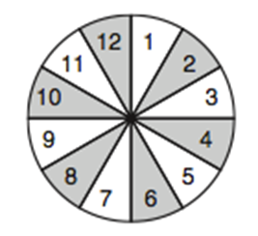
- Olivia randomly spins the spinner below once. Find:

  - P(Spin a number greater than 9 or spin a multiple of 3)

  - P(Spin an even number or spin an odd number)

  - P(Spin an even number or spin a multiple of 4)

  - P(Spin a multiple of 4)^{c}

- A pair of dice is tossed. Find the probability that the first roll has a sum of 6 and the second roll has a sum of 8.

- A pair of dice is tossed twice. Find the probability that you roll doubles on the first toss and doubles on the second toss.

- A coin is tossed 4 times in succession. Find the probability of getting two heads followed by two tails.

- If P(Sun in California) = 0.93 and P(Sun in Michigan) = 0.53, Assume that these are independent find:

  - P(Sunny in California and Michigan) = __________

  - P(Sunny in California or Michigan) = __________

  - P(Not sunny in Michigan and sunny in California) = __________

  - P(Sun in California)^{c} = __________

- Compute the conditional probability P(B|A) given that:

  - P(A) = 0.61, P(B) = 0.18, and P(A and B) = 0.07

  - P(A) = 0.2, P(B) = 0.5, and P(A and B) = 0.2

- Compute the conditional probability P(A|B) given that:

- P(A) = 0.61, P(B) = 0.18, and P(A and B) = 0.07

- P(A) = 0.2, P(B) = 0.5, and P(A and B) = 0.2

- A pair of dice is tossed. Find the probability that the sum of the two dice is 8 given that the sum is even.

- A pair of dice is tossed. Find the probability that the sum of the two dice is 8 given that the sum is greater than 6.

- A pair of dice is tossed. Find the probability that doubles are rolled given that the sum of the two dice is less than 7.

- A standard deck of playing cards is shuffled and three people choose a card one at a time. Find the probability that all three cards are face cards if

  - (a) the cards are chosen with replacement.

  - (b) the cards are chosen without replacement.

- A box contains three medium t-shirts, five large t-shirts, and 4 extra large t-shirts.

  - If someone randomly chooses three t-shirts from a box, find the probability that the first t-shirt is a large, the second is a medium, and the third is a large if the shirts are chosen with replacement.

  - If someone randomly chooses three t-shirts from a box, find the probability that the first t-shirt is a large, the second is a medium, and the third is a large if the shirts are chosen without replacement.

Directions: Find the probability that each event occurs using a standard deck of 52 cards with replacement and without replacement.

 | With Replacement | Without Replacement
- First card drawn is an ace and the second card is an ace

- First card drawn is a face card and the second card is a 9

- First card drawn is an ace and the second card drawn is not an ace

- First card drawn is red, second card drawn is red, and third card drawn is red

- A friend who works in a big city owns two cars, one small and one large. Three-quarters of the time he drives the small car to work, and one-quarter of the time he drives the large car. If he takes the small car, he usually has little trouble parking, and so is at work on time with probability 0.9. If he takes the large car, he is at work on time with probability 0.6. Draw a tree diagram to represent all possible outcomes. Given that he was on time on a particular morning, what is the probability that he drove the small car?

- In a study of pleas and prison sentences, it is found that 45% of the subjects studied were sent to prison. Among those sent to prison, 40% chose to plead guilty. Among those not sent to prison, 55% chose to plead guilty. Draw a tree diagram to represent all possible outcomes. Given that a subject entered a guilty plea, what is the probability that the person was not sent to prison?

- Erick, a college senior, interviews with Acme Corp. and Mills Inc. The probability of receiving an offer from Acme is 0.35, from Mills is 0.48, and from both is 0.15. Draw a Venn Diagram and then find the probability of receiving an offer from either Acme Corp. or Mills Inc. but not both.

- A group of college students were surveyed on which sport they enjoyed participating in. Results are recorded in the Venn Diagram.
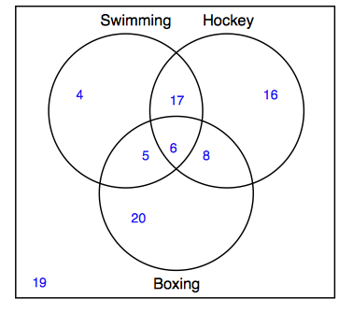

  - How many students like swimming and hockey?
  - How many students like swimming or hockey?
  - How many students only like boxing?

- When a player is selected at random from a high school boys’ baseball team, the probability that he is a pitcher is 0.35, the probability that he is right-handed is 0.79, and the probability that he is a right-handed pitcher is 0.26. Draw a Venn Diagram and then determine the probability that a player who is randomly chosen is a left-handed pitcher.

- There is a 60% chance that a student will get college credit on the AP Exam. Assume each student is independent and the probability stays the same (even if this doesn’t make sense). If I examine 8 students, find:
  - Describe how you know this is binomial:

  - Fill in the probabilities: (show how you get the probability with the formula at least once)

X = # students passed 0 1 2 3 4 5 6 7 8

P (X) = probability

  - P ( 5 students pass)

  - P (no more than 3 students pass)

  - P ( at least 6 students pass)

  - How many students would you expect to pass?

- There is a 60% chance a student will get credit on the AP Exam (again). You count the number of students that take the exam until you find a student that fails.
  - Describe how you know this is geometric:

  - Fill in the probabilities:

X = # of students until one fails 1 2 3 4 5 6 …….

P(X) = probability

  - Find P( the 3rd student is the first one to fail)

  - Find P(it takes 5 or more students until one fails)

  - How many students would you expect until you find one that fails.

