6.1 and 6.2 Worksheet #2 (Review)

Basic Probability Rules

- A single 6-sided die is rolled once.
- Find P(2 or 5)

- Find P (Even)

- Find P (2 or Even)

- Find P (2 and Even)

- A spinner has 4 equal sectors colored yellow, blue, green and red. The spinner is spun once.
- Find P(Red or Blue)

- Find P(Red and Blue)

- Find P (Green)

- A glass jar contains 1 red, 3 green, 2 blue, and 4 yellow marbles. If a single marble is chosen from the jar, find:
- P(Yellow)

- P(Green)

- P(Yellow or Green)

- P(Yellow and Green)

- A single card is chosen at random from a standard deck of 52 playing cards, find:
- P(King)

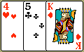
- P(King or Club)

- P(King and Club)

- P (Face)

- P (Ace or Face)

- Two cards are drawn find:
- P(King and then an Ace) with replacement

- P (King and then an Ace) without replacement

- In a math class of 30 students, 17 are boys and 13 are girls. On a test, 4 boys and 5 girls got a 4.0. If a single student is randomly chosen, find:
- P(Girl)

- P(4.0)

- P(Girl and 4.0)

- P(Girl or 4.0)

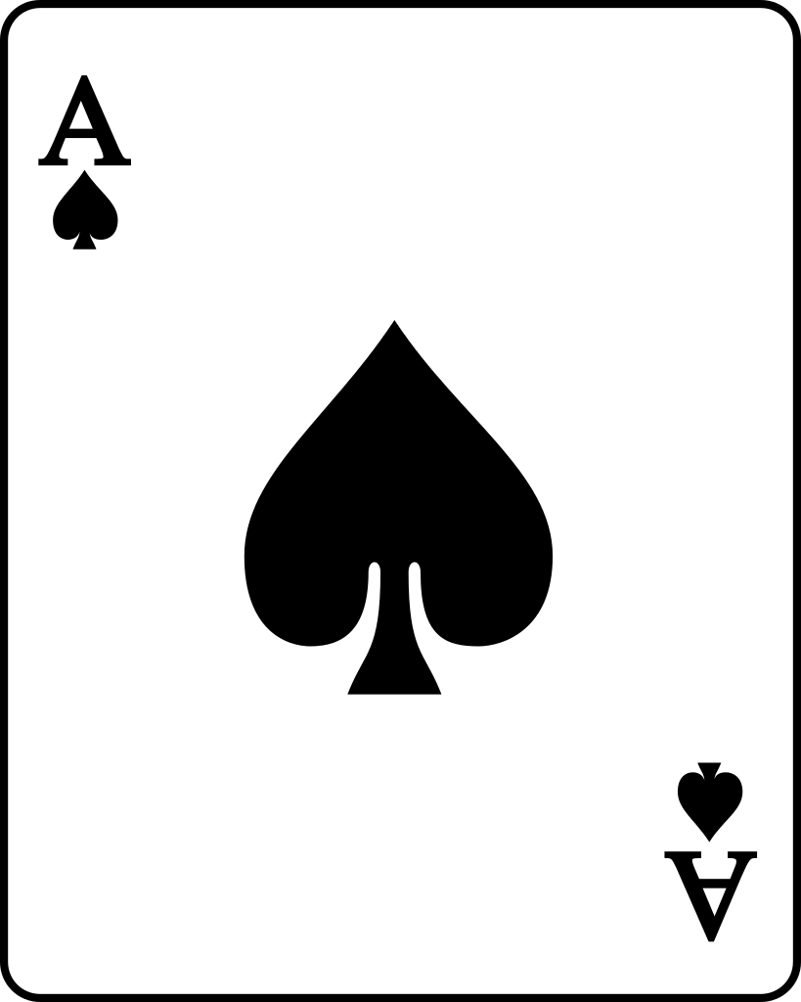
- A card is drawn randomly from a standard deck of playing cards. You win $10 if the card is a spade or an ace. What is the probability that you will win the game?

- A jar contains 6 red marbles and 4 black marbles. Two marbles are drawn. The first is drawn and then replaced before a second marble is drawn. What is the probability that you get a black marble and then another black marble?

- There are 8 white, 4 red, and 3 blue marbles in a jar. Determine the following probabilities assuming the first marble is drawn and is replaced before the second marble is drawn.
- P(White)

- P(Blue or White)

- P(Red or White or Blue)

- P(White and then Blue)

- P(Blue ^{c} )

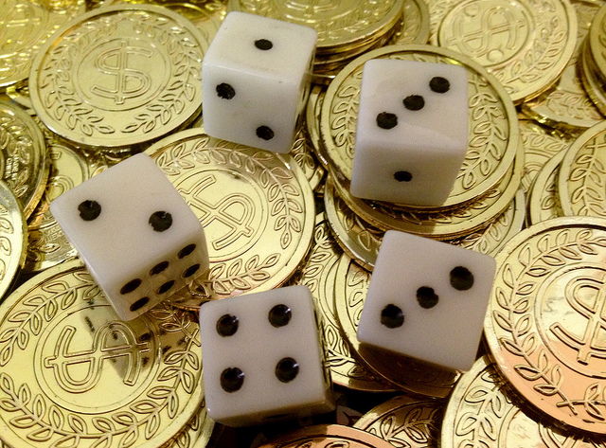
- Suppose you toss a coin and roll a die:
- How many outcomes are possible?

- List the sample space:

- P (Head and Even)

- P(H)

- P(1, 2, or 3 on die)

- Suppose a person is having two surgeries performed at the same time by different operating teams. If the chances of success for surgery A are 85% and the chances for success for surgery B are 90%, what are the chances that both surgeries will fail?

