3.1 & 3.2 WS

Correlation & Association
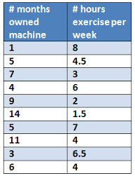
- Graph the data and then find the correlation of the following data set by filling in the tables below:
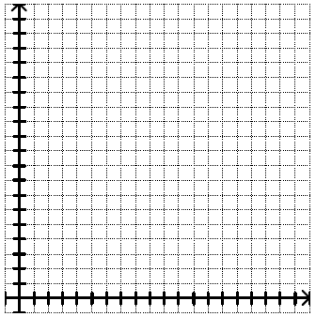

Describe the association (in context):

x | y | Zx | Zy | Zx Zy
x̅ = _____ y̅ = _____ Σ Zx Zy= _________
Sx= _____ Sy=______ $\frac{\sum{z_{x}z_{y}}}{(n-1)}$ = r = ______

- Ninth grade students at the Webb Schools go on a 30-mile backpacking trip each fall. Before leaving, students and their backpacks are weighed. The table below shows the body weights and backpack weights of 8 members of a group.
Graph the data and then find the correlation using the chart below:

Name Weight (lb) Backpack Weight (lb)
Amble 120 26
Belay 116 28
Cliff 103 24
Dodder 187 30
Elog 109 24
Faller 131 29
Gumper 165 35
Hock 116 28

Describe the association (in context):

X | y | Zx | Zy | Zx Zy

x̅ = _____ y̅ = _____ Σ Zx Zy= _________
Sx= _____ Sy=______ $\frac{\sum{z_{x}z_{y}}}{(n-1)}$ = r = ______

- A student wonders if tall women tend to date taller men. She measures herself, her dormitory roommate and the women in the next few rooms at her dorm in college. Then she measures the height of the next man that each woman dates. The data she collects is listed below. Graph the data and calculate the correlation between the heights of women and men:
Women Heights (inches) Men Heights (inches)
66 72
64 68
66 70
65 68
- 71

65 65

Describe the association (in context):

x | y | Zx | Zy | Zx Zy

x̅ = _____ y̅ = _____ Σ Zx Zy= _________
Sx= _____ Sy=______ $\frac{\sum{z_{x}z_{y}}}{(n-1)}$ = r = ______

